
Case IH Agriculture Equipment, Inc.

For More Information, contact:
Scott Rasch 262/636-6615
scott.rasch@cnh.com
or
Ryann Greve 262/636-5921
ryann.greve@cnh.com

Press Materials

CASE IH SPONSORS WISCONSIN SNOW SCULPTING COMPETITION IN RACINE

RACINE, Wis. (January 20, 2012)
Racine is home to the Case IH Magnum™ tractor and they’re usually made of iron, but the Magnum that will welcome visitors to this weekend’s The Big Chill event is made of snow. Case IH is sponsoring this free event, held in Monument Square, which will name Wisconsin’s 2012 snow sculpting champion.
Event attendees can watch 16, two-person sculpting teams that will be in action Friday, January 20, through Sunday, January 22. To kick off the event, sculptors carved 12 ice blocks into creative designs last weekend, which can be seen along Main and Sixth Streets. The public is encouraged to vote for the ice and snow sculptures they think should receive the People’s Choice honor.
“Case IH is proud to participate in local community events like The Big Chill,” says Scott Rasch, Case IH Public Relations Manager. “We expect many of our employees and their families will join in the fun.”
The 2011 Wisconsin state snow sculpting champion and this year’s The Big Chill event chairman, Jeff Shawhan, is carving a Case IH Magnum tractor snow sculpture. Red lights will illuminate the sculpture, reinforcing the brand’s legendary identity. The Magnum is one of two exhibition-only sculptures sponsored by local businesses.
Shawhan owns The Elements Gallery in Racine and has been snow sculpting for
(more)
15 years. The three-time state snow sculpting champion also teaches 3D design in the art department at Concordia University in Mequon. Shawhan will compete in the U.S. Nationals Snow Sculpting Competition on January 30 and 31 in Lake Geneva.
Winners of this year’s competition in Racine will participate in the 2013 national snow sculpting competition in Lake Geneva. The winners will be announced Sunday, January 22, at 2 p.m.
“Case IH is pleased to have a Magnum tractor featured in its hometown and in this unique, creative art medium,” says Rasch.
Case Construction, a sister company of Case IH, donated the use of a Case skid steer to form the blocks of snow artists will carve during the event.

Case IH is a global leader in agricultural equipment, committed to collaborating with its customers to develop the most powerful, productive, reliable equipment – designed to meet today’s agricultural challenges. Challenges like feeding an expanding global population on less land, meeting ever-changing government regulations and managing input costs. With headquarters in the United States, Case IH has a network of dealers and distributors that operates in over 160 countries. Case IH provides agricultural equipment systems, flexible financial service offerings and parts and service support for professional farmers and commercial operators through a dedicated network of professional dealers and distributors. Productivity enhancing products include tractors; combines and harvesters; hay and forage equipment; tillage tools; planting and seeding systems; sprayers and applicators; site-specific farming tools and utility vehicles. Case IH is a brand of CNH (NYSE: CNH), a majority-owned subsidiary of Fiat Industrial S.p.A. (FI.MI).
###
For more information, visit www.caseih.com.

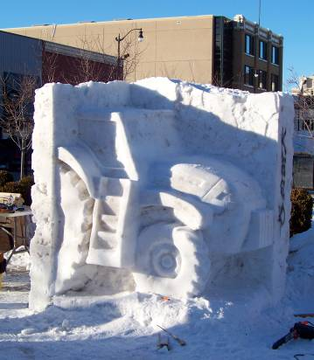

Photo caption:
Jeff Shawhan is carving a Case IH Magnum tractor snow sculpture featured at The Big Chill event held this weekend in Racine. Case IH is sponsoring the event, which names the 2012 Wisconsin snow sculpting champion.

